MACHINE LEARNING · PART 2· CLUSTERING SERIES
Three Measures of Similarity
How these work
Which One Should You Trust?
Euclidean, Manhattan and Minkowski distances explained in form of a story, with data for four customers, and a end goal which is : finding who all belongs together.
EUCLIDEAN DISTANCE MANHATTAN DISTANCE MINKOWSKI DISTANCE

Story So Far….
"In our last post, we introduced machine learning in terms of what is machine learning and we also understood was two different branches of Machine Learning which are :- Supervised Learning and Unsupervised Learning. “
We started with Unsupervised Learning algorithm :- Clustering. In our last post, we understood what is Clustering and why it is categorized as a Unsupervised Learning Algorithm.
We discussed that in clustering our ultimate/end goal is to group similar data points together. In simple terms suppose we have a data of 1000 people. In clustering all we are trying to do is put these 1000 customers in some group based on some features/characteristics. People who have similar attributes/characteristics they will be part of the same group.
Question:- How will we decide which all datapoints are similar to each other so, that we can place them in one group/cluster.
In order to understand which all data points are similar to each other and which all should go in one cluster we can use different metrics and these metrics will help us with an answer. These metrics can be classified in two major categories and they are:
- Distance metrics(In simple words, calculate the distance between two data points, the lesser the distance between two points the more similar they are and they go in the same cluster and the higher the distance they will go to separate clusters.)
- Similarity metrics(the more similar two data points are they go together in one cluster/group).
We started with Distance Metrics in our last blog and understood about Euclidean Distance with the help of an example where we had customers(we had their Age and their Monthly Income).
Let's pick up exactly where we left off same data (quick recap of Euclidean Distance), but this time we will extend this blog in understanding different distance metrics as well.

Let’s suppose we have a small business and we are trying to make sense from our customer base. We collected data for four customer and we have their: Age( in years) and Monthly Income (in Rs).
End Goal:
Find, out of all the four customer who all are "similar". To put in more simple terms, we are trying to find out who among these four customers who all show similar traits/characteristics, so that we can group them together put them in one group/cluster and design different strategies for different groups. As you cannot deal with everyone in same manner like the way you have conversation with a 30 year old person you will not have the conversation in same manner with a 5 year old kid.
The another reason to create group/clusters of the customers is because it is not possible for me to come up with a plan/strategy for every single customer.
Our Data:
Customer | Age (years) | Monthly Income (₹) | Plot Position on graph
A | 20 | 1,000 | (20, 1000)
B | 30 | 1,200 | (30, 1200)
C | 70 | 1,100 | (70, 1100)
D | 50 | 5,000 | (50, 5000)

From the above data, visually, A, B, and C look like they are similar and they can be clustered together in one cluster as they all have low income, while D seems to be away from them as D has a high income.
Though C is different in terms of Age from A and B still we feel that as the Income for C is not that significantly different from A and B and hence, we can group A,B and C together.
Like we will create two Clusters :- Cluster 1 (A,B,C) and Cluster 2(D)

Have a look at the graph below created from our data to get more clarity as to how the data points will look on a graph.

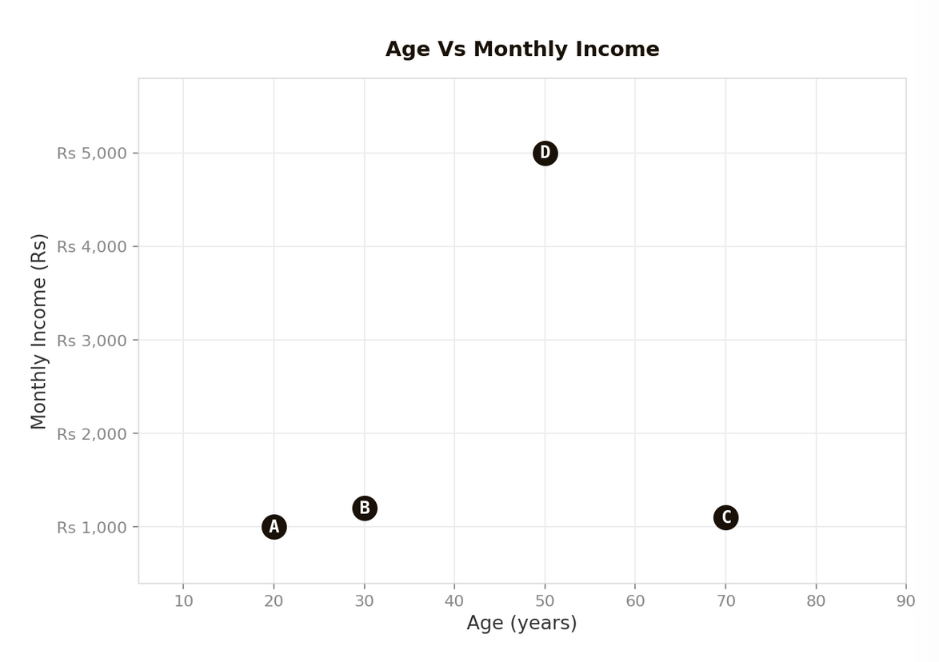

In the above visualisation we can sense that A and B seem to be closer, C is bit far and D is very far so technically, looking at it we can see that we might create three clusters.
Cluster 1(A,B)
Cluster 2 (C)
Cluster 3 (D)

This way of looking at the datapoints on a graph and deciding the clusters is not good/feasible because of the below reasons:

- You only have four data points as of now what if you have 1million data points visually it will not be possible to understand which points are close/far based on a mere visualisation.
- As of now you only have two columns (Age and Income) so it was easy to plot the points on the graph and come with a conclusion. However, in real world what if you have 10 variables. Creating a graph itself might not be possible.
- Lastly, looking at the graph and deciding on something is based on pure intuition. There is no mathematical/ statistical evidence for what you are saying.

Hence, graphs will give you an intuition we still need some measures/metrics in place which can give us more solid approach in terms of on what basis we are grouping/clustering the data.

This is where one of our metrics “Distance Metrics” comes in picture. Distance metrics works on simple logic.
Calculate the distance between two data points and same way calculate for every pair of data point, whichever data point has least distance those are grouped together.

In our data as of now we have 4 data points A, B, C and D.
Calculate distances between :
A-B -> Distance between A and B
A-C -> Distance between A and C
A-D -> Distance between A and D
B-C -> Distance between B and C
B-D -> Distance between B and D
C-D -> Distance between C and D

Find which pair has the least distance and that pair goes in one cluster/group. There are different distance algorithms that we can use. We will start with calculating the distances with “Euclidean distance” algorithm first and then will see other distance metrics as well.

Before, we start doing this calculation, have a look at the below graph it indicates what we thought or started with initially, that we will create two clusters. Cluster1 (A,B,C) and Cluster2 (D)

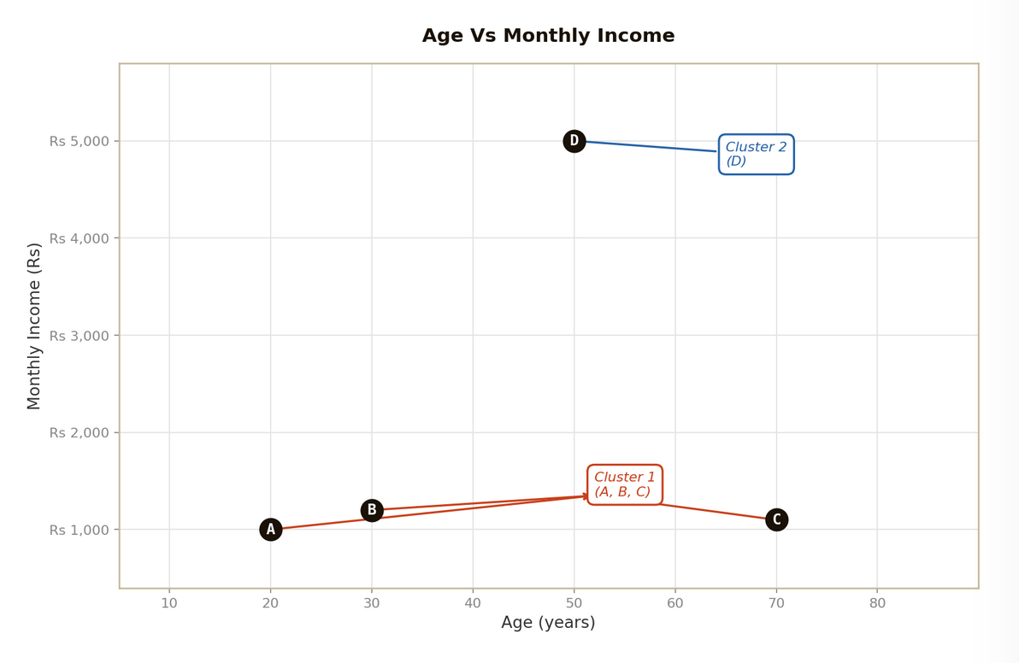

IMP POINT:
Important to Note:
If you observe in the data Income values ranges between 1000 – 5000 are which are much higher than Age values which ranges between 20- 70. This clearly indicates that income will dominate any distance metric/calculation.
In order to solve this problem we need to scale our data before we do any calculation. There are various scaling methods available like Min-Max scaling or Z-score scaling.
In our blog we will compute distances based on raw data plus will also show how to scale the data and after scaling also we will calculate the distances as in real world, one should always apply Min-Max or Z-score scaling before clustering.

1 | Euclidean Distance (Without any scaling)

Imagine a football field. You are standing in one corner of the field and your friend is standing in another corner of the filed.
If you want to reach to your friend technically you have two ways:
- First, You can walk on the boundary lines like (first go straight, then turn right, then again straight and then turn left and then again straight and you will reach to your friend).
- Second, and the most easy and shortest way is walk diagonally across the field and reach to your friend.

The second way a straight path between you and your friend. This is what Euclidean distance measures (a straight line distance).
The formula for calculation “Euclidean Distance” is mentioned below:
FORMULA
d(A,B) = √[ (x₂−x₁)² + (y₂−y₁)² ]
General form for n dimensions: d = √[ Σ (xᵢ − yᵢ)² ]

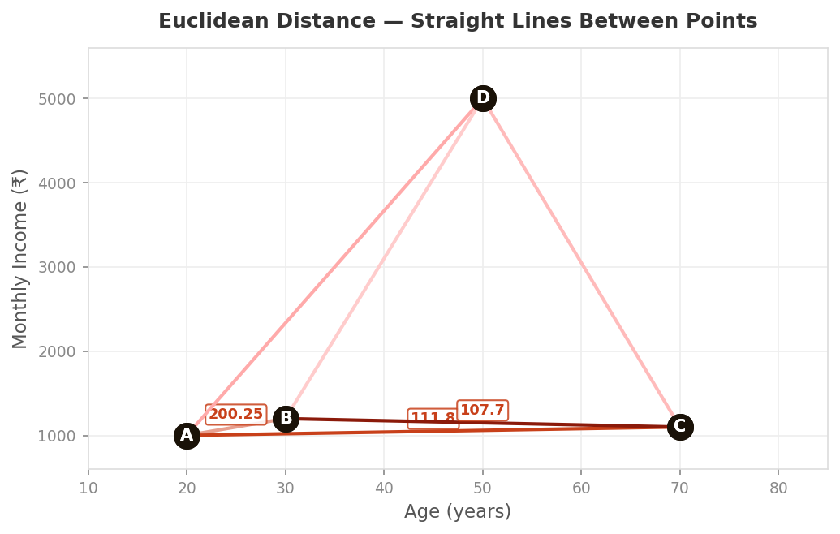
Distances between all the points in our data shown visually

The below table shows the calculation of Euclidean Distance based on our dataset.
Customer | Age (years) | Monthly Income (₹) | Plot Position on graph
A | 20 | 1,000 | (20, 1000)
B | 30 | 1,200 | (30, 1200)
C | 70 | 1,100 | (70, 1100)
D | 50 | 5,000 | (50, 5000)

Pair | Calculation | Euclidean Distance
A – B | √[(30−20)²+(1200−1000)²] | 200.25
A – C | √[(70−20)²+(1100−1000)²] | 111.80
A – D | √[(50−20)²+(5000−1000)²] | 4,000.11
B – C | √[(70−30)²+(1100−1200)²] | 107.70
B – D | √[(50−30)²+(5000−1200)²] | 3,800.05
C – D | √[(50−70)²+(5000−1100)²] | 3,900.05

Conclusion: Euclidean tells us that A, B, C are relatively close (100–200 apart) while D is far away (3,800–4,000).
Hence, technically A,B and C can form one cluster and D is another cluster. So, Cluster1 has three data points (A,B,C) and Cluster2 only has one data point (D)
However, Euclidean is sensitive to scale, as Monthly Income value for D is so high that it dominates the Euclidean Distance calculation. We can clearly see in the data that the age difference between A-D is just 30 years but because the Income has 4000 difference it outweighs the calculation and that is why the distance between A-D is so high.
However, even if we scale the data then as well the final conclusions of cluster might not change.

Let’s do one thing. I will introduce you to Min-Max Scaling and do the entire Euclidean Distance calculation on scaled data as well and let’s see what are the results.

Why Do We Scale First?
Before calculating any distance, we must scale our data. Without scaling, features with larger numbers completely overpower features with smaller numbers, giving us misleading distances.
Look at our dataset.
Customer | Age (years) | Monthly Income (₹) | Plot Position on graph
A | 20 | 1,000 | (20, 1000)
B | 30 | 1,200 | (30, 1200)
C | 70 | 1,100 | (70, 1100)
D | 50 | 5,000 | (50, 5000)

Age ranges from 20 to 70 a spread of just 50 units. Income ranges from Rs 1,000 to Rs 5,000 a spread of 4,000 units. When we compute Euclidean Distance on raw data, the income difference dominates the calculation more than the age difference. Doesn’t sound fair as both the variables/features should have equal say/importance in the calculations.

In order to take care of the above problem we will go ahead and scale our data using Min-Max scaling. There are different scaling techniques available but for simplicity as of now we will go ahead with Min-Max Scaling. Will introduce other scaling techniques in future blogs.
Step 1: Understand the Min-Max Formula
Min-Max Scaling transforms every single data point into a number between 0 and 1. The smallest value in a column becomes 0. The largest becomes 1. Everything else falls proportionally in between.

MIN-MAX SCALING FORMULA
Scaled Value = (X - X_min) / (X_max - X_min)

X = the original value we want to scale
X_min = the smallest value in that column
X_max = the largest value in that column
Result = always falls between 0 and 1

Step 2: Find Min and Max for Each Feature
Before we can scale anything, we need to identify the minimum and maximum values for each column.

AGE COLUMN VALUES: 20, 30, 70, 50
Minimum Age = 20 (Customer A)
Maximum Age = 70 (Customer C)
Range (Max - Min) = 70 - 20 = 50

INCOME COLUMN VALUES: 1000, 1200, 1100, 5000
Minimum Income = Rs 1,000 (Customer A)
Maximum Income = Rs 5,000 (Customer D)
Range (Max - Min) = 5000 - 1000 = 4,000

Step 3: Scale Each Customer — One by One
Now we apply the Min-Max formula to every single data point. We do this for each customer, for both features (Age and Income).

Customer A → Age = 20, Income = Rs 1,000
Scaled Age (A) = (20 - 20) / (70 - 20)
= 0 / 50
= 0.00

Scaled Income (A) = (1000 - 1000) / (5000 - 1000)
= 0 / 4000
= 0.00

Customer B → Age = 30, Income = Rs 1,200
Scaled Age (B) = (30 - 20) / (70 - 20)
= 10 / 50
= 0.20

Scaled Income (B) = (1200 - 1000) / (5000 - 1000)
= 200 / 4000
= 0.05

Customer C → Age = 70, Income = Rs 1,100
Scaled Age (C) = (70 - 20) / (70 - 20)
= 50 / 50
= 1.00

Scaled Income (C) = (1100 - 1000) / (5000 - 1000)
= 100 / 4000
= 0.025

Customer D → Age = 50, Income = Rs 5,000
Scaled Age (D) = (50 - 20) / (70 - 20)
= 30 / 50
= 0.60

Scaled Income (D) = (5000 - 1000) / (5000 - 1000)
= 4000 / 4000
= 1.00

Notice what happened to Customer D:
Before scaling: Income = Rs 5,000 was the dominant number in every distance calculation.
After scaling: Income = 1.00 which is exactly the same scale as Age = 0.60.
Now both features contribute fairly and equally to the distance calculations below.

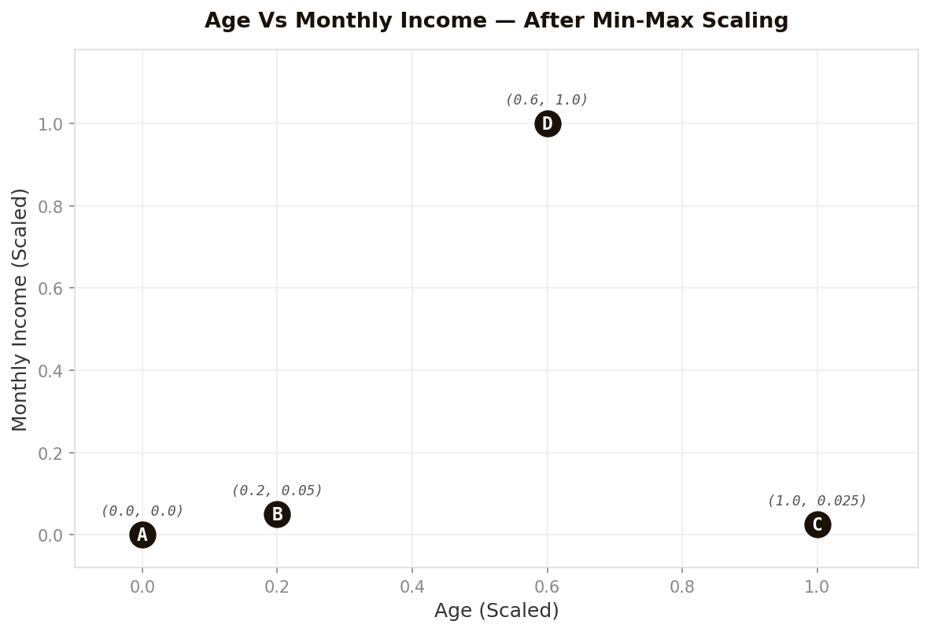
Scatter plot after Min-Max Scaling — all values now between 0 and 1

Scaled Data for reference:
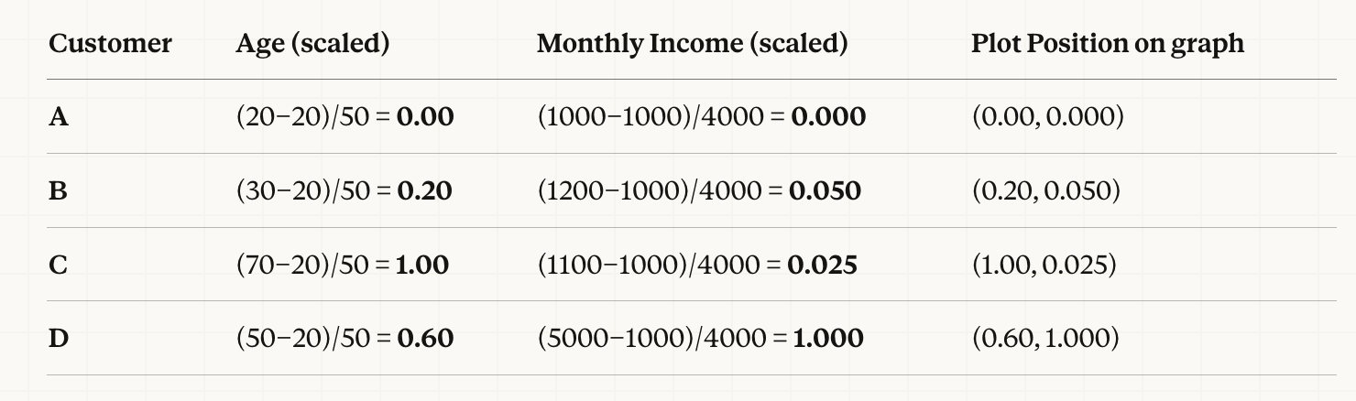
Step 5: Calculate Euclidean Distance on Scaled Data
Now that our data is scaled, we apply the Euclidean Distance formula to the scaled values. Every calculation below uses the scaled values i.e. values between 0 and 1, not the original raw values.

EUCLIDEAN DISTANCE FORMULA (on scaled data)
d(P1, P2) = √[ (Age₂ - Age₁)² + (Income₂ - Income₁)² ]

Both Age and Income are now scaled values (0 to 1)
Smaller distance = more similar customers
Larger distance = less similar customers

Calculating All 6 Pair Distances
We have 4 customers, so there are 6 unique pairs: A-B, A-C, A-D, B-C, B-D, C-D. Let's calculate each one step by step.

Pair A – B
Step 1: Age difference = 0.20 - 0.00 = 0.20
Step 2: Income difference = 0.05 - 0.00 = 0.05
Step 3: Square both = 0.20² + 0.05²
= 0.0400 + 0.0025
= 0.0425
Step 4: Square root = √0.0425
Distance (A-B) = 0.2062

Pair A – C
Step 1: Age difference = 1.00 - 0.00 = 1.00
Step 2: Income difference = 0.025 - 0.00 = 0.025
Step 3: Square both = 1.00² + 0.025²
= 1.0000 + 0.000625
= 1.000625
Step 4: Square root = √1.000625
Distance (A-C) = 1.0003

Pair A – D
Step 1: Age difference = 0.60 - 0.00 = 0.60
Step 2: Income difference = 1.00 - 0.00 = 1.00
Step 3: Square both = 0.60² + 1.00²
= 0.3600 + 1.0000
= 1.3600
Step 4: Square root = √1.3600
Distance (A-D) = 1.1662

Pair B – C
Step 1: Age difference = 1.00 - 0.20 = 0.80
Step 2: Income difference = 0.025 - 0.05 = -0.025 → use absolute: 0.025
Step 3: Square both = 0.80² + 0.025²
= 0.6400 + 0.000625
= 0.640625
Step 4: Square root = √0.640625
Distance (B-C) = 0.8004

Pair B – D
Step 1: Age difference = 0.60 - 0.20 = 0.40
Step 2: Income difference = 1.00 - 0.05 = 0.95
Step 3: Square both = 0.40² + 0.95²
= 0.1600 + 0.9025
= 1.0625
Step 4: Square root = √1.0625
Distance (B-D) = 1.0308

Pair C – D
Step 1: Age difference = 0.60 - 1.00 = -0.40 → use absolute: 0.40
Step 2: Income difference = 1.00 - 0.025 = 0.975
Step 3: Square both = 0.40² + 0.975²
= 0.1600 + 0.950625
= 1.110625
Step 4: Square root = √1.110625
Distance (C-D) = 1.0539

Step 6: Final Distance Summary
All six distances computed. Let's put this in form of a table and see what they tell us about which customers are similar.

Pair | Scaled Positions | Euclidean Distance | Similarity
A – B | (0.00,0.00) (0.20,0.05) | 0.2062 | Very Similar
A – C | (0.00,0.00) (1.00,0.025) | 1.0003 | Different
A – D | (0.00,0.00) (0.60,1.00) | 1.1662 | Very Different
B – C | (0.20,0.05) (1.00,0.025) | 0.8004 | Moderate
B – D | (0.20,0.05) (0.60,1.00) | 1.0308 | Very Different
C – D | (1.00,0.025) (0.60,1.00) | 1.0539 | Very Different

What the Distances tells us
→ A and B are the most similar pair (distance = 0.2062). Close in both age and income.
→ A, B, C all have very low scaled incomes (0.00–0.05), naturally forming Cluster 1.
→ D is far from everyone (distances 1.03–1.17), forming its own Cluster 2 entirely due to its high income.

Now, we understood one of the Distance Metric which was “Euclidean Distance”. Let’s understand two more distance metrics which is “Manhattan Distance” and “Minkowski Distance”

2 | Manhattan Distance

Suppose you want to go from your house to a shop that is diagonally across the block. Even though the shop is “straight ahead” if you look across the buildings, you cannot walk through the buildings. So you go one street forward and then turn right, so you have to follow the lanes to reach to that shop.
That's Manhattan distance. Instead of measuring the straight-line distance (Euclidean Distance), it measures the total travel along each axis separately and adds them up. Also called L1 distance or City Block distance.
INTUITION
Think of it this way. To travel from your home at (20, 1000) to a friend's house at (30, 1200), you must drive:
10 units East (age difference)
200 units North (income difference)
Manhattan distance = 10 + 200 = 210. You counted every block you drove, not the shortcut through the building.

FORMULA
d(A,B) = |x₂−x₁| + |y₂−y₁|
General form for n dimensions: d = Σ |xᵢ − yᵢ|

The | | means "absolute value" — ignore negative signs

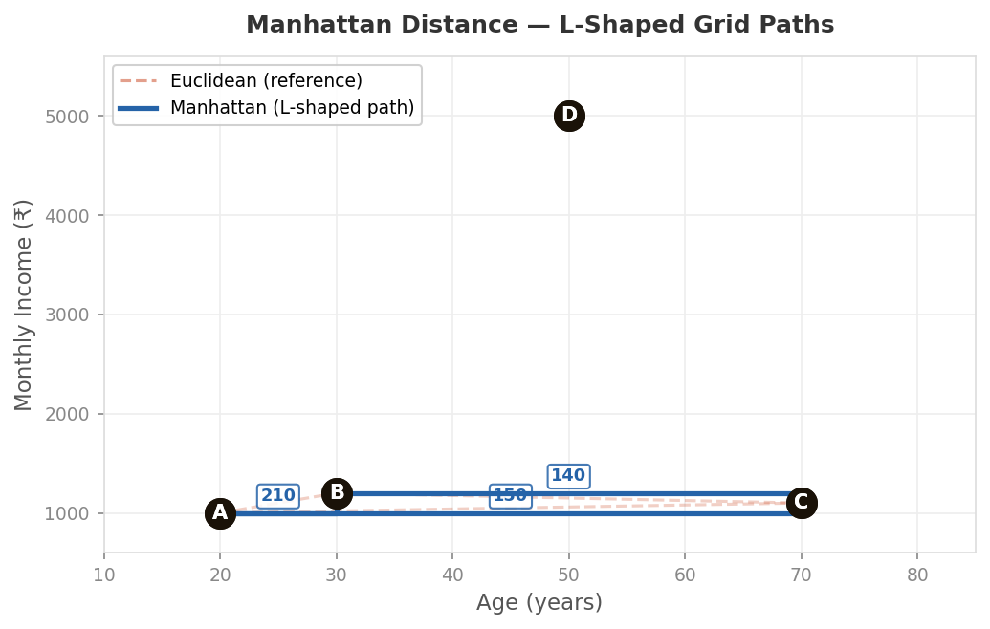
Manhattan Distance — L-shaped grid paths (blue), with Euclidean reference shown dashed

Calculating Manhattan Distances — All Pairs

Pair | Age diff |Δx| | Income diff |Δy| | Manhattan Distance
A – B | |30−20| = 10 | |1200−1000| = 200 | 210
A – C | |70−20| = 50 | |1100−1000| = 100 | 150
A – D | |50−20| = 30 | |5000−1000| = 4000 | 4,030
B – C | |70−30| = 40 | |1100−1200| = 100 | 140
B – D | |50−30| = 20 | |5000−1200| = 3800 | 3,820
C – D | |50−70| = 20 | |5000−1100| = 3900 | 3,920

Conclusion: Manhattan reaches the same conclusion as Euclidean which is A, B, C are more similar so they can form one cluster and D is very different and hence it will go in another cluster.
But notice the distances are slightly different in magnitude. Manhattan tends to give larger numbers than Euclidean because it can't take the diagonal shortcut.
In high dimensions, Manhattan often outperforms Euclidean because it doesn't exaggerate the impact of one very different feature. In simple terms what I am trying to say is that in Euclidean Distance we square the differences so, if one feature has a very big difference, squaring it makes it extremely large.
On the other hand, Manhattan Distance just adds the difference without squaring them so the big difference does not explode in importance.

3 | Minkowski Distance

“Minkowski is a generalised distance formula where we can control which distance metric we need to use using a parameter called p.
p = 1 (Manhattan Distance)
p= 2 (Euclidean Distance)
p =3 (Minkowski Distance)

In simple terms you can think that Minkowski Distance is the parent formula, and Manhattan and Euclidean are just special cases of it.
Think of it as a generalised distance. It introduces one extra ingredient: a parameter called p. By changing p, you change the "shape" of how distance is measured. It's like switching between different rulers , each with a slightly different philosophy.

FORMULA
d(A,B) = [ |x₂−x₁|ᵖ + |y₂−y₁|ᵖ ] ^(1/p)
When p = 1 → Manhattan Distance (L1)
When p = 2 → Euclidean Distance (L2)
When p → ∞ → Chebyshev Distance (maximum of all differences)

THE KNOB ANALOGY
Imagine Minkowski distance as a volume knob:
p = 1 (low): You treat every dimension equally — each unit of age difference costs the same as each unit of income difference. Grid travel. (Manhattan Distance)
p = 2 (middle): You allow diagonal shortcuts. Differences combine in a balanced, geometric way. Straight-line travel. (Euclidean Distance)
p = 3+ (high): Large differences in any single dimension start to dominate the result. The biggest gap gets amplified more and more.

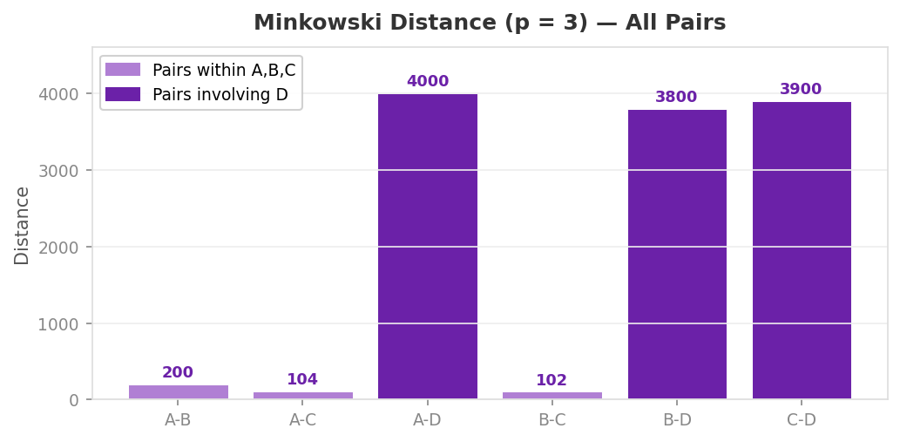
Minkowski Distance (p = 3) — bars for D-pairs are significantly taller (income gap dominates)

Calculating Minkowski Distances (p = 3)
For each pair we compute |Δx|³ + |Δy|³ and then take the cube root:

Pair | |Δx|³ | |Δy|³ | Sum | Minkowski (p=3)
A – B | 1,000 | 8,000,000 | 8,001,000 | 200.01
A – C | 125,000 | 1,000,000 | 1,125,000 | 104.00
A – D | 27,000 | 64,000,000,000 | ≈ 64 Billion | 4,000.03
B – C | 64,000 | 1,000,000 | 1,064,000 | 102.13
B – D | 8,000 | ≈ 54.9 Billion | ≈ 54.9 Billion | 3,800.02
C – D | 8,000 | ≈ 59.3 Billion | ≈ 59.3 Billion | 3,900.01

Conclusion: With p = 3, the income gap between D and everyone else gets even more emphasis. Large differences are punished harder than with Euclidean. The conclusion remains the same , but Minkowski gives us control over how aggressively we penalise outlier differences.

Putting all three side by side
"Same four customers. Same six pairs. Three different rulers. What do the numbers say — and do they agree?"

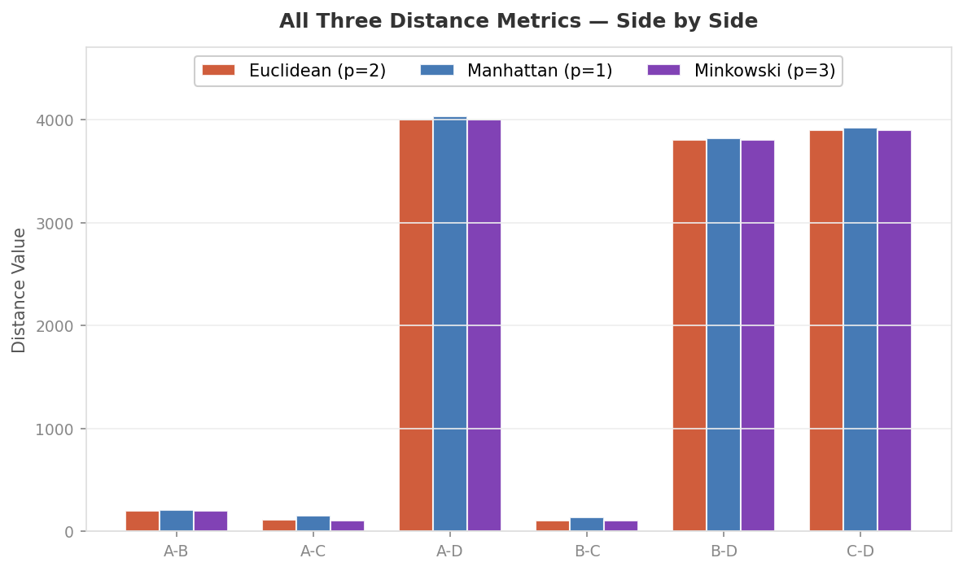
All Three Distance Metrics — Grouped bar chart comparing Euclidean, Manhattan, and Minkowski (p=3) for all 6 pairs

Pair | Euclidean (p=2) | Manhattan (p=1) | Minkowski (p=3) | Cluster?
A – B | 200.25 | 210 | 200.01 | Together
A – C | 111.80 | 150 | 104.00 | Together
B – C | 107.70 | 140 | 102.13 | Together
A – D | 4,000.11 | 4,030 | 4,000.03 | Apart
B – D | 3,800.05 | 3,820 | 3,800.02 | Apart
C – D | 3,900.05 | 3,920 | 3,900.01 | Apart

Final Conclusion:
All three distance metrics tell the same clustering story here. A, B, C belong in one cluster. D stands alone. The numbers differ slightly, but the conclusion does not. This is often the case in well-separated data — the choice of metric matters more in tricky, overlapping situations.

How Do They Differ in Character?

Feature | Euclidean | Manhattan | Minkowski
Shape of Path | Straight line : shortest possible route | L-shaped grid : horizontal then vertical | Adjustable : depends on p value
Sensitivity | Sensitive to outliers; squaring amplifies big differences | More robust to outliers; does not square differences | Controllable — high p = more sensitive, low p = more robust
Best For | Continuous numeric data, spatial/geometric problems | Data with many features; grid-like real-world movement | When you want to experiment and tune behaviour
High Dimensions | Can suffer : "curse of dimensionality" | Often performs better than Euclidean | p=1 recommended as dimensions grow
Analogy | Bird flying between two cities | Taxi navigating city blocks | A shape-shifting ruler you can tune

Putting It All Together — The Story of the Three Rulers
Imagine you run a market research company. A client gives you data on their four customers — A, B, C and D — and asks you to segment them. You pull out your three rulers.

1 | You first try the Euclidean ruler. It measures the straight-line distance, as if you could draw a line directly between two customer dots on a map. It quickly tells you: A, B, C are all within 200 units of each other. D is over 4,000 units away. Clean split. Two clusters.

2 | You cross-check with the Manhattan ruler. This one insists on travelling along the grid — like a taxi that can't cut corners. It measures separately: how different are they in age? How different in income? Then adds those up. Slightly larger numbers, but the same verdict. A, B, C together. D alone.

3 | You try the Minkowski ruler (p = 3). This one punishes large differences more harshly than Euclidean. But again, the conclusion holds. In fact, with this data, all three rulers agree perfectly — because the separation between D and the others is just that obvious.

4 | You present the result: Two customer segments. Cluster 1 (A, B, C) — young to middle-aged, modest income. Cluster 2 (D) — high income, very different spending potential. Your client now knows exactly how to design two different marketing campaigns.

The Key Lessons
→ Euclidean Distance is your go-to default. It's intuitive (straight-line), mathematically clean, and works well when your features are on similar scales and your data is not too high-dimensional.
→ Manhattan Distance is your safer choice in higher dimensions and noisy data. Because it doesn't square the differences, it's less sensitive to one single feature being wildly different. Think of it as the more forgiving ruler.
→ Minkowski Distance is the Swiss Army knife. It contains both Euclidean (p=2) and Manhattan (p=1) as special cases. When in doubt, you can tune p and let cross-validation guide you to the best choice.
! Always scale your data first. Income (1000–5000) dominated age (20–70) in every metric. In real datasets with 100+ features, scaling is not optional — use Min-Max or Z-score normalisation before computing any distance.

Coming Up Next
Now that we've mastered the three distance rulers, we're ready to move on to Similarity Metrics i.e. Cosine Similarity and Jaccard Index which approach the "how alike are you?" question from a completely different angle.
And then, finally, we dive into the actual clustering algorithms - K-Means, DBSCAN and watch these distances and similarity do their real work.

The goal, as always: explain concepts in a simple, visual, and intuitive way — step by step, with no step skipped.

Machine Learning, Explained Simply · Clustering Series · Part 1 · Distance Metrics

